Strain measurement

Introduction:
In general terms strain is defined as a geometrical measure of deformation representing the relative displacement between particles in the material body. It measures how much a given displacement differs locally from a rigid-body displacement. Piezoelectric transducers are used widely to measure the strain in materials due to the fact that in piezoelectric materials, electric charge is separated when the materials is strained (and vice versa)and that is recorded which minimizes the error to a large extent.
Aim:
To measure the lateral strain, longitudinal strain and volumetric strain of beam when it is subjected to axial tensile load. This experiment covers normal strain under axial loading; we are going to expand upon this by looking at non-axial loading, in particular, the loading of a beam.
Theory:
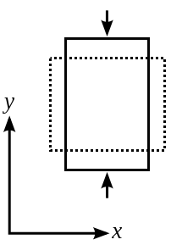
Strain is defined as the ratio of change in dimension to original dimension of a body when it is deformed. It is a dimensionless quantity as it is a ratio between two quantities of same dimension. The types of Strains include lateral, longitudinal (linear), volumetric and shear strain.
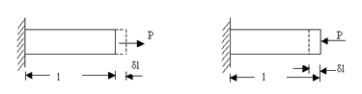
Suppose a rectangular bar of width b, depth d and length L be subjected to an axial load. the deformation of the member will take place such that the length of the member will increase the lateral dimension .
Poisson’s ratio:
When the deformation of the member is within the elastic limit it is found that the ratio of the lateral strain to the longitudinal strain is a constant for a given material. This ratio is called poison’s ratio and is usually denoted by μ and it usually varies from 0.2 to 0.5.
Bending theory:
When a beam is loaded with some external loading, moment & shear force are set resulting in strain. The bending moment at a section tends to deflect the beam & internal stresses tend to resist its bending. This internal resistance is known as bending stresses.
The bending stress at any section can be obtained by beam equation.
f = (M/I) y

Where, M= moment at considered section.
f = extreme fiber stresses at considered section.
I = Moment of inertia at that section.
y= Extreme fiber distance from neutral axis.
F(max) = maximum stress at the farthest fiber i.e. at y(max) from neutral axis.
Young’s Modulus of elasticity :
Its defined as the ratio of normal stress to normal strain within elastic limit.From bending theory the deflection of the beam is calculated as
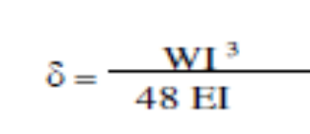
This formula can be used to get E value given with all the other values.

Here ,
W = Load acting at the center, N
I = Length of the beam between the supports mm
E = Young’s modulus of material of the beam, N/mm2
I = Second moment of area of the cross- section(e.i.,
moment of inertia)of the beam, about the neutral
axis

As per bending theory bending stress is calculated as
Where,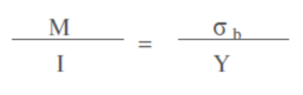
M = Bending moment, Nmm
I = Moment of inertia.
Y=Deflection of the beam
= bending stress,N/mm2
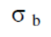
Procedure:
- Measure the dimensions of the beam to be loaded and place it on the loading frame with knife edged supports at 2 ends of the beam(Simply supported beam).Also calculate the Moment of inertia of the rectangular beam which will be used in the calculation part)
- Place a dial gauge at the center of the beam to measure the deflection of the beam. Note the initial reading of the dial gauge.
- Apply loads in increments of 50N (say) and measure the corresponding deflection values of the beam by noting the final dial gauge reading.
- Load the beam till failure and note the max load taken and the corresponding max deflection value (Ymax).
- Calculate the Max moment taken by the beam (which is given by Mmax=WL/4).
- Using the experimental data the strain values of the material can be calculated.

Observation:
Dimensions of the beam:
L=………………….m (test length)
b=…………………m (width)
t= ………………….m (thickness)

Table 1
Sl. No | Load | Deflection
From graphical data the slope of Load v/s deflection graph the slope yields Young’s modulus of elasticity =……………………….Gpa
Table 2
Sl No | Load,W | Deflection  δ (mm) | Moment at mid span, M | 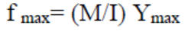  ( 𝜎 ) | Linear strain  Є=E* 𝜎 | Lateral Strain  Δb/b | Poisson’s Ratio ( μ)
Average Poisson’s ratio calculated = …………………….

Extra reading Material:
www.wikipedia.com
http://www.me.rochester.edu/courses/ME242/Lab%20Files/A2_StrainGages_2003.doc
http://courses.washington.edu/mengr354/jenkins/notes/chap3.pdf
http://silver.neep.wisc.edu/~lakes/PoissonIntro.html

Quiz:
What is Poisson’s ratio for perfectly elastic material?
Poisson’s ratio is generally positive. (T/F)

